Name-Anmol yadav

SAP ID -500083814

BATCH- DevOps

EXPERIMENT 3

AIM: Working with Docker Volume

Steps to Complete:

1. View all Volume in Docker

Command: docker volume ls

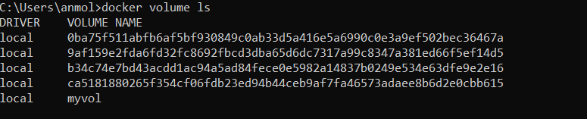

1. Create a new Volume

Command: docker volume create myvol2

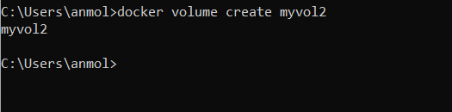

1. Mount a Volume with a container

Command: docker run -it -v myvol2:/data redis /bin/bash

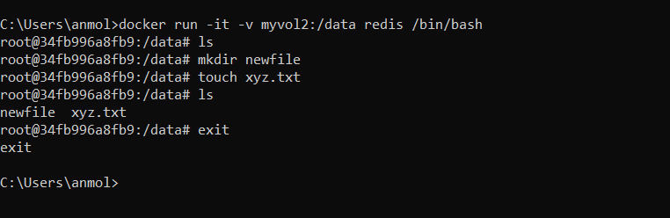

1. Create another container and Mount with the same Volume

Command: docker run -it -v myvol2:/data redis /bin/bash

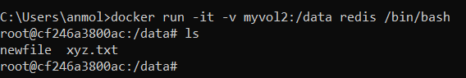

1. See the complete working of the container

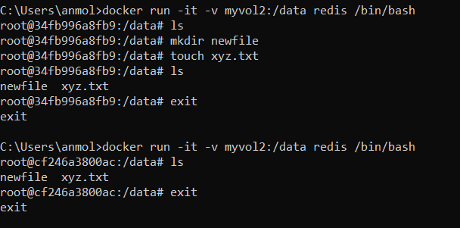

1. Exited from container and restart again to see the persistent of Docker Volume

Command: docker attach 34fb….

